# Terraform Create VM

# 

## Tutorial

Create directory and required files

$ mkdir terrafVM && cd $_ && touch main.tf variables.tf outputs.tf && ls -la

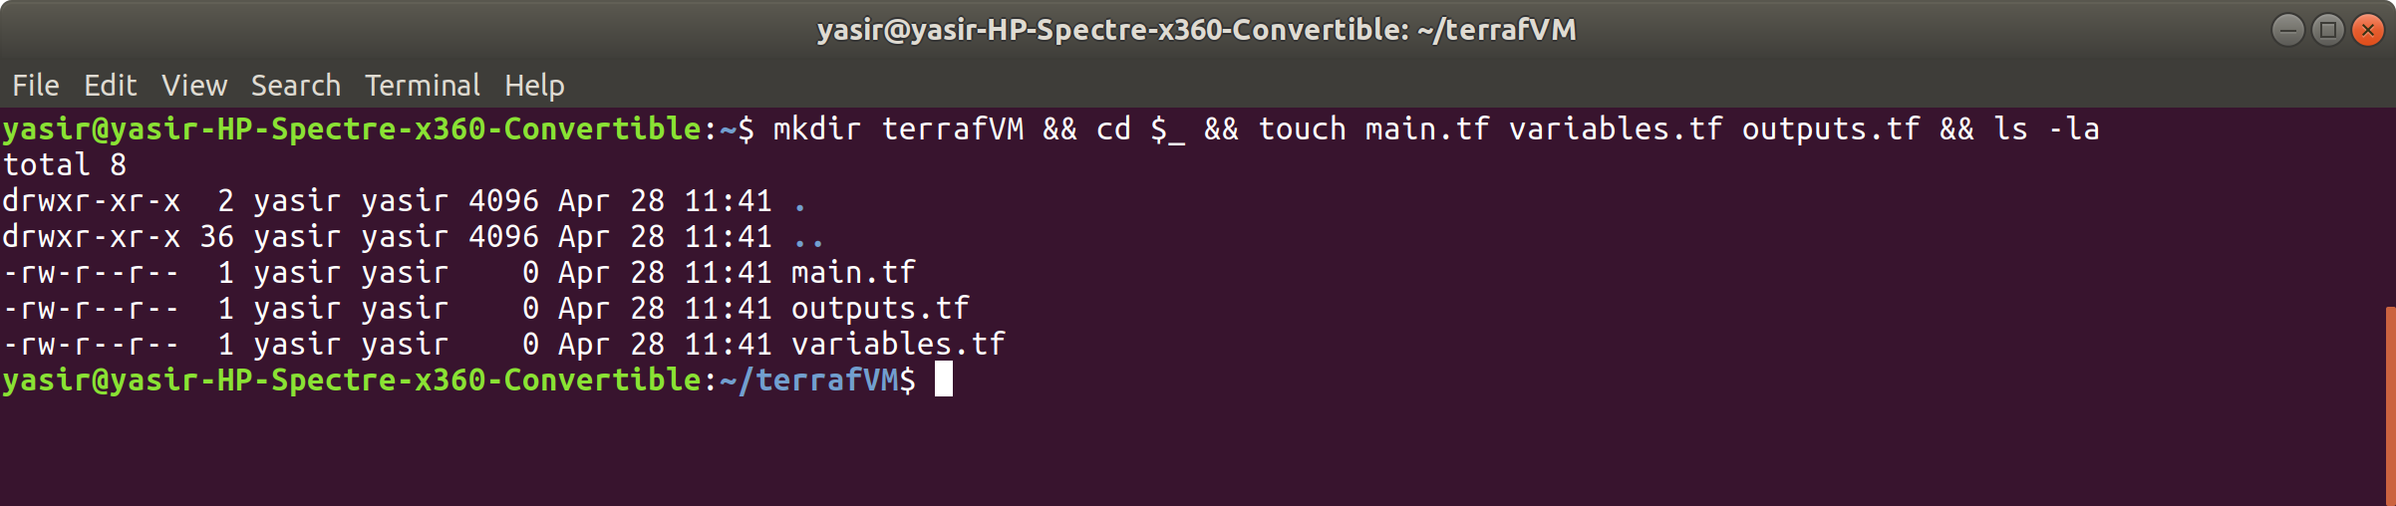

Goto Terraform resources website and look for Azure virtual machine

<https://www.terraform.io/docs/providers/azurerm/r/virtual_machine.html>

This example provisions a Virtual Machine with Managed Disks. Other examples of the azurerm_virtual_machine resource can be found in [the ./examples/virtual-machines directory within the Github Repository](https://github.com/terraform-providers/terraform-provider-azurerm/tree/master/examples/virtual-machines)

type this in main.tf file

$ vim main.tf

resource "azurerm_resource_group" "main" {

name = "${var.prefix}-resources"

location = "East US 2"

}

resource "azurerm_virtual_network" "main" {

name = "${var.prefix}-network"

address_space = ["10.0.0.0/16"]

location = azurerm_resource_group.main.location

resource_group_name = azurerm_resource_group.main.name

}

resource "azurerm_subnet" "internal" {

name = "internal"

resource_group_name = azurerm_resource_group.main.name

virtual_network_name = azurerm_virtual_network.main.name

address_prefix = "10.0.2.0/24"

}

resource "azurerm_network_interface" "main" {

name = "${var.prefix}-nic"

location = azurerm_resource_group.main.location

resource_group_name = azurerm_resource_group.main.name

ip_configuration {

name = "testconfiguration1"

subnet_id = azurerm_subnet.internal.id

private_ip_address_allocation = "Dynamic"

}

}

resource "azurerm_virtual_machine" "main" {

name = "${var.prefix}-vm"

location = azurerm_resource_group.main.location

resource_group_name = azurerm_resource_group.main.name

network_interface_ids = [azurerm_network_interface.main.id]

vm_size = "Standard_DS1_v2"

storage_image_reference {

publisher = "Canonical"

offer = "UbuntuServer"

sku = "16.04-LTS"

version = "latest"

}

storage_os_disk {

name = "myosdisk1"

caching = "ReadWrite"

create_option = "FromImage"

managed_disk_type = "Standard_LRS"

}

os_profile {

computer_name = "hostname"

admin_username = "yasirsatti"

admin_password = "Password1234!"

}

os_profile_linux_config {

disable_password_authentication = false

}

}

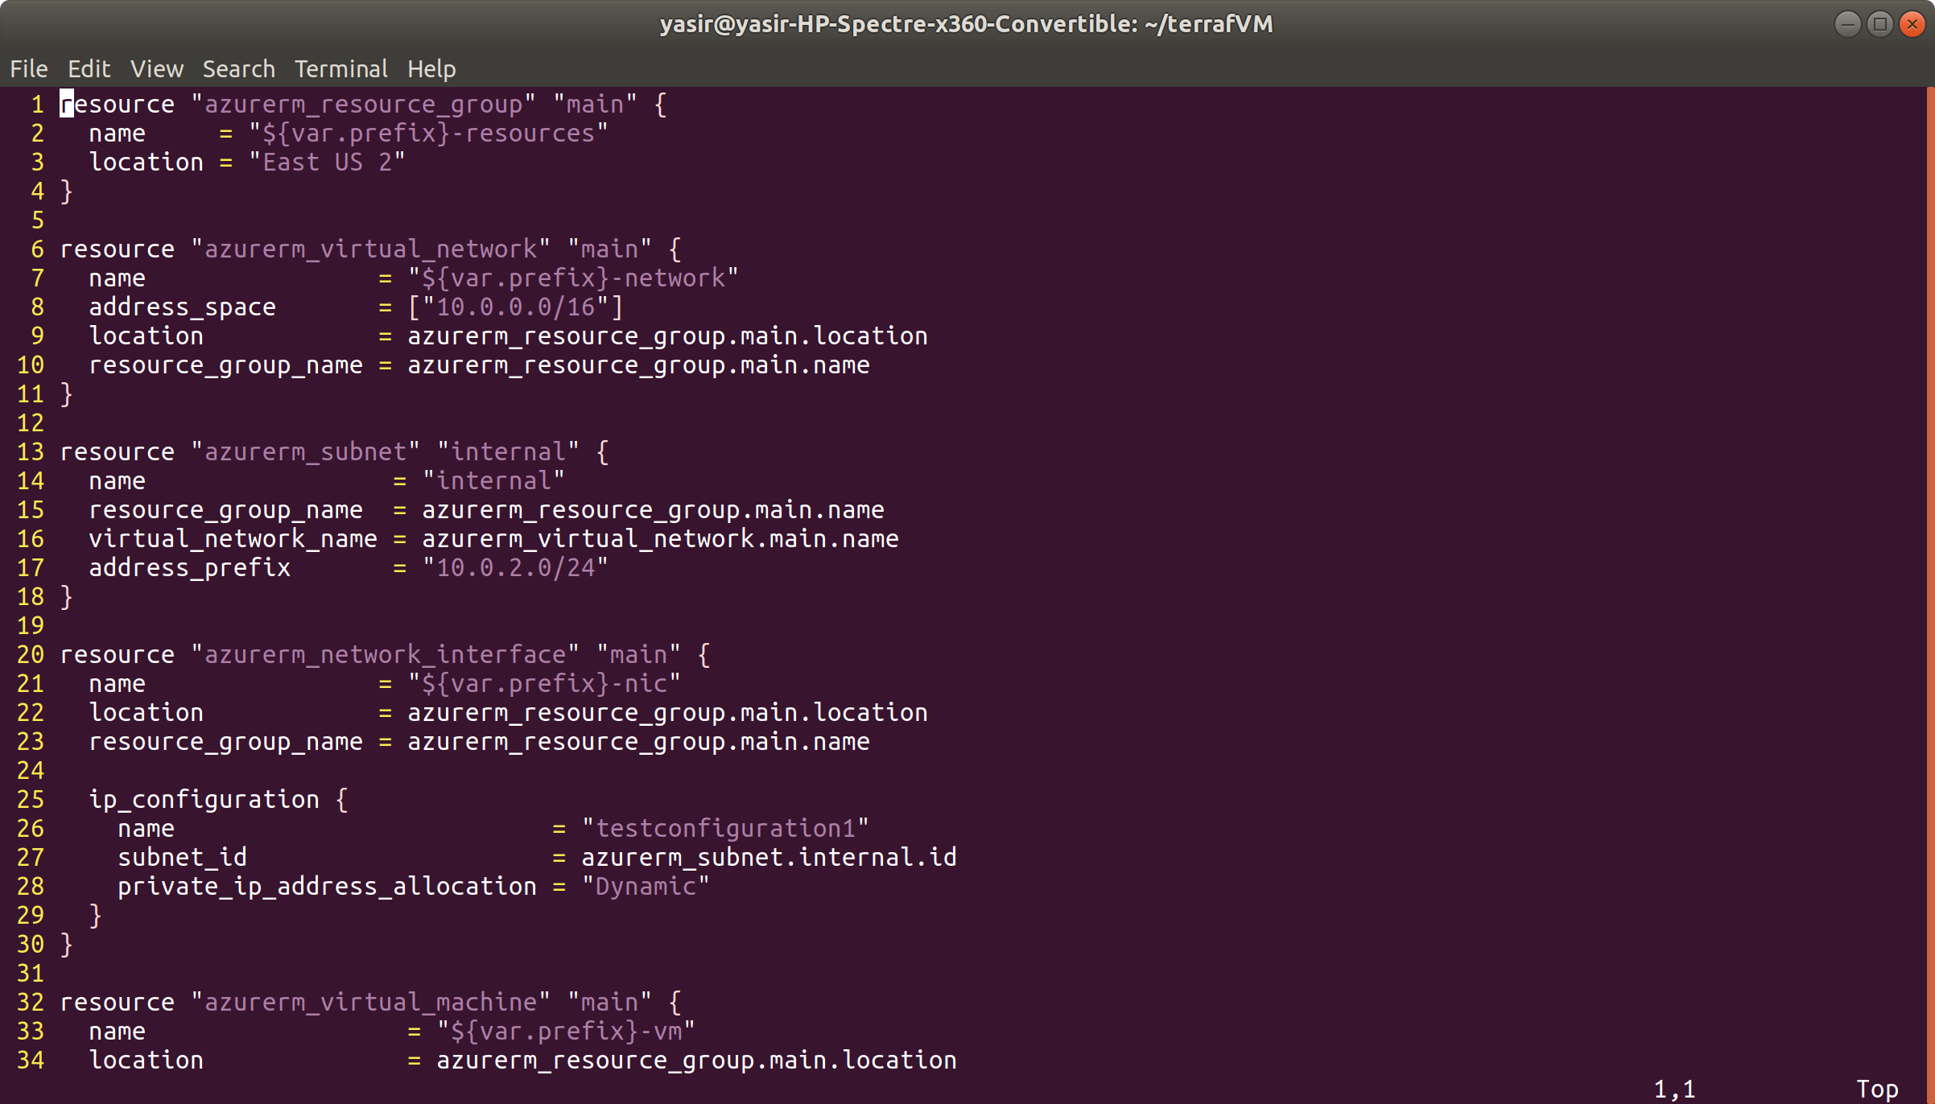

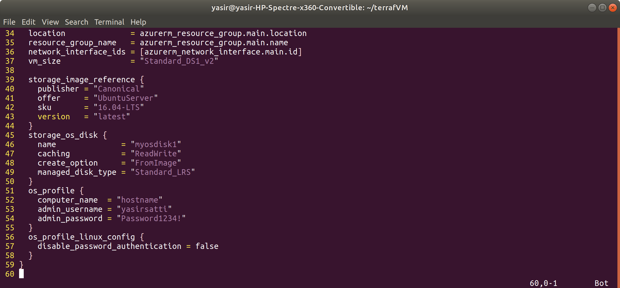

type this in variable.tf

$ vim variable.tf

variable "prefix" {

default = "yasProd"

}

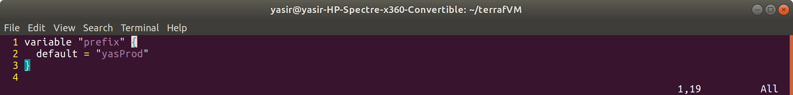

ssh configuration

in main.tf under os_profile_linux_config block disable the password authentication

disable_password_authentication = true

create ssh key block

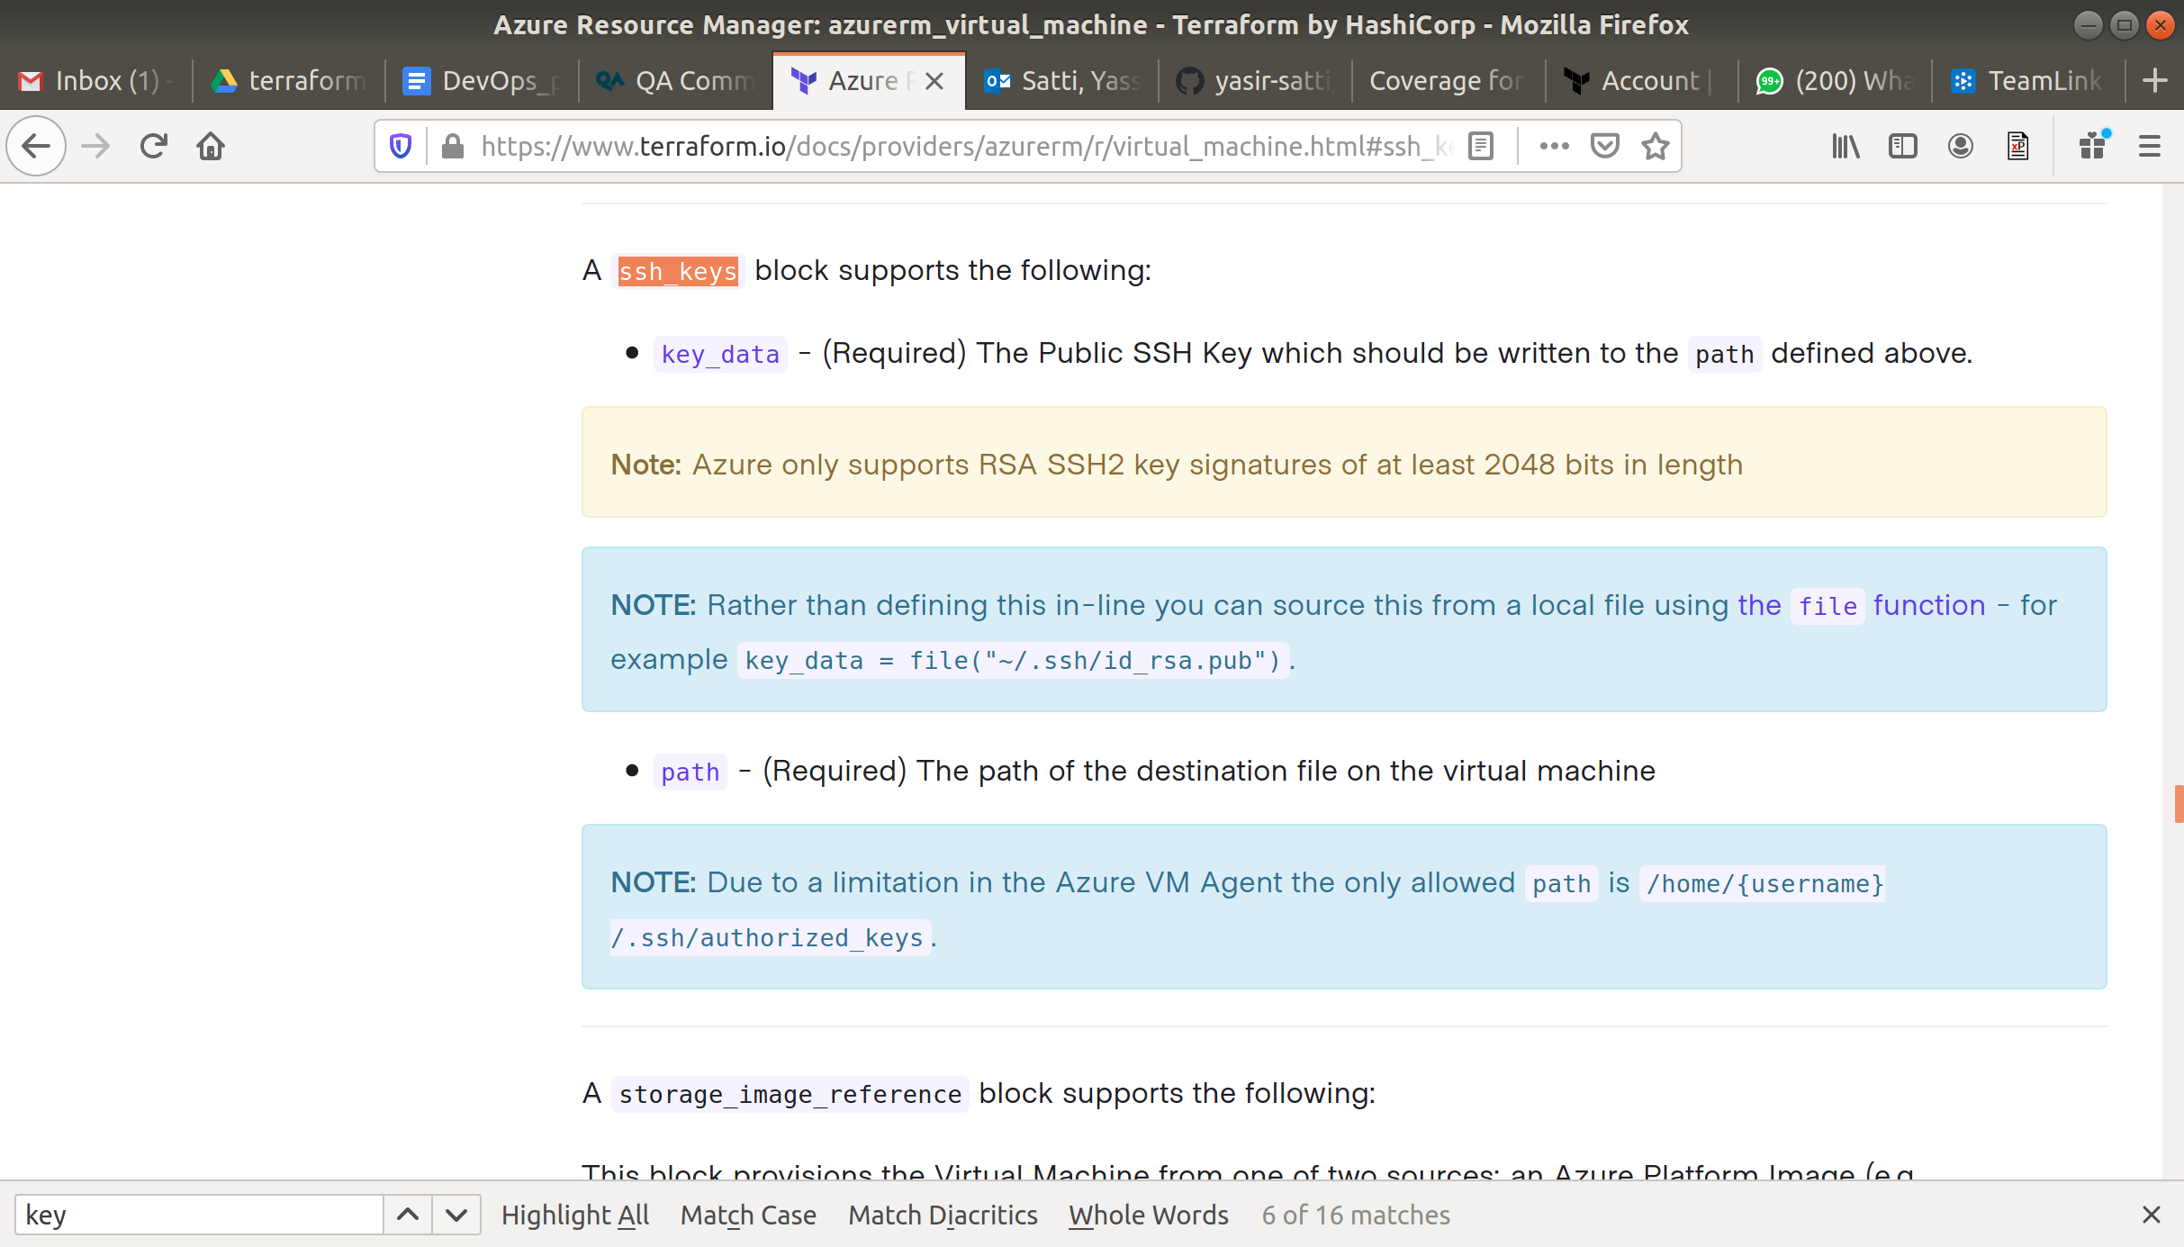

os_profile_linux_config {

disable_password_authentication = true

ssh_keys {

key_data = file("~/.ssh/id_rsa.pub")

path = "/home/yasirProd/.ssh/authorized_keys"

}

}

Public ip

Get the public IP after the VM is created, so create a public IP block. So navigate to network resources and look for Azure public IP

<https://www.terraform.io/docs/providers/azurerm/r/public_ip.html>

So type in the following in main.tf file below “azurerm_subnet” resource block

resource "azurerm_public_ip" "main" {

name = "${var.prefix}-PublicIp"

location = azurerm_resource_group.main.location

resource_group_name = azurerm_resource_group.main.name

allocation_method = "Static"

}

Now to capture the new public IP

<https://www.terraform.io/docs/providers/azurerm/r/network_interface.html>

In the resource "azurerm_network_interface" add the public ip

public_ip_address_id = azurerm_public_ip.main.id

In main.tf add below at the start of the file

provider "azurerm" {

version = "2.0.0"

features {}

}

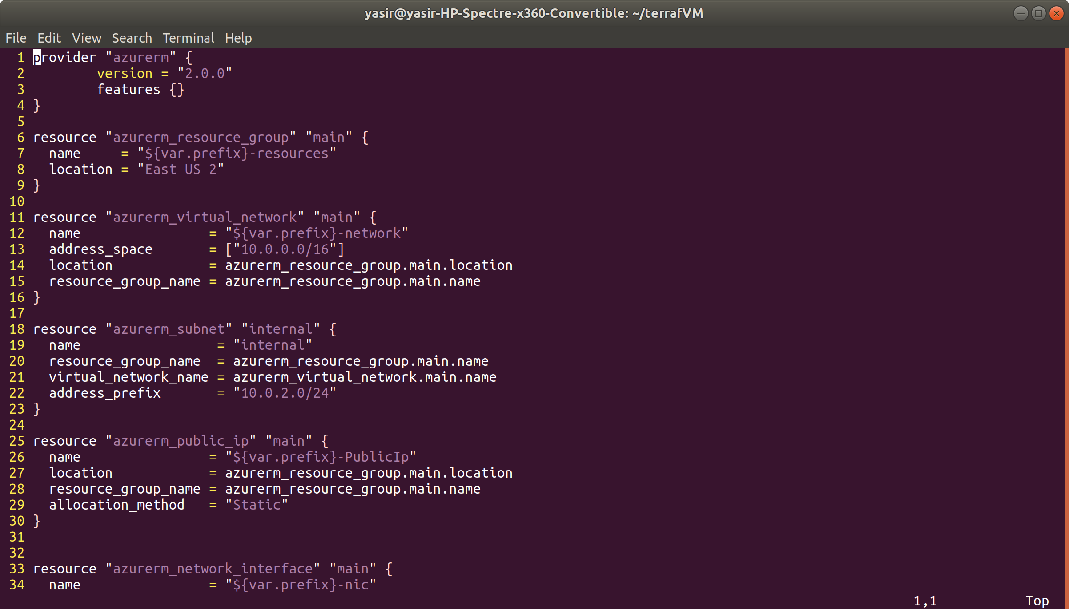

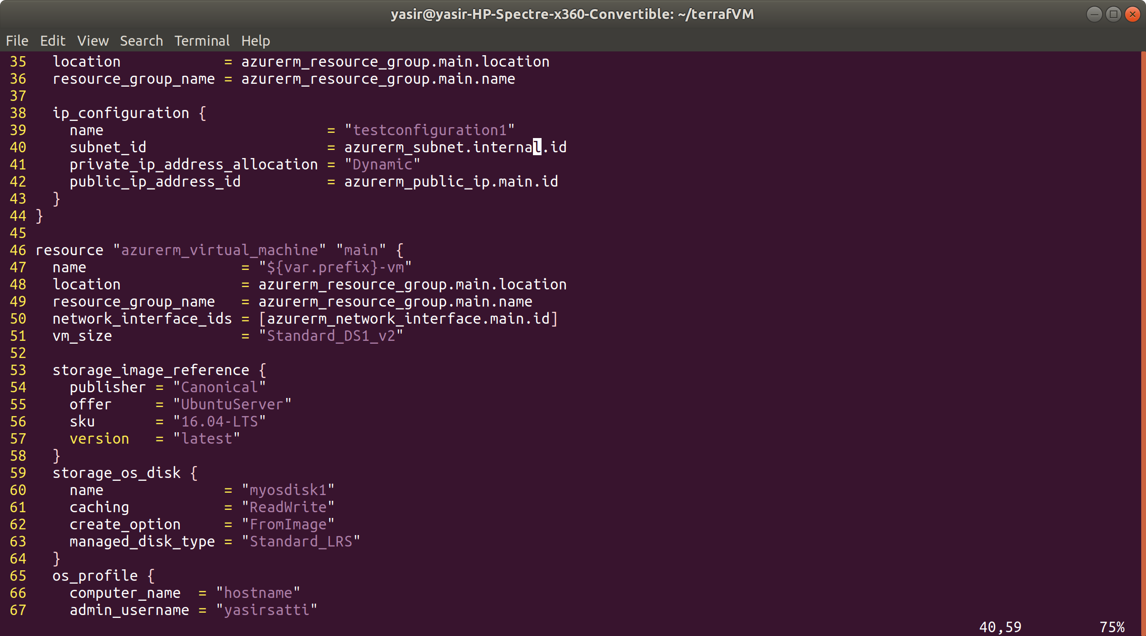

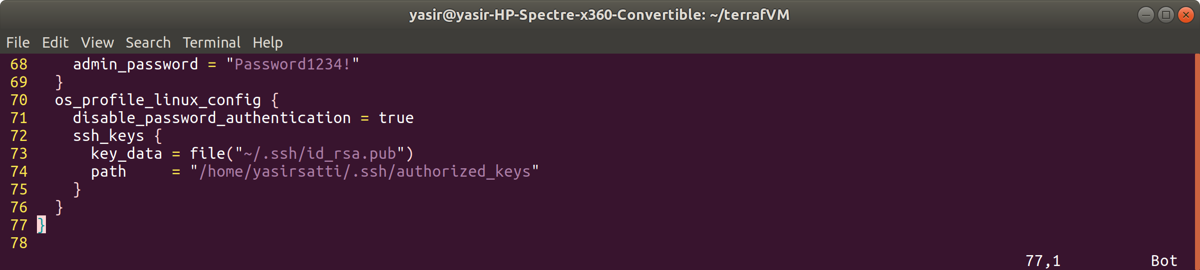

Add the following to outputs.tf file

output "prod_pub_ip" {

value = azurerm_public_ip.main.ip_address

}

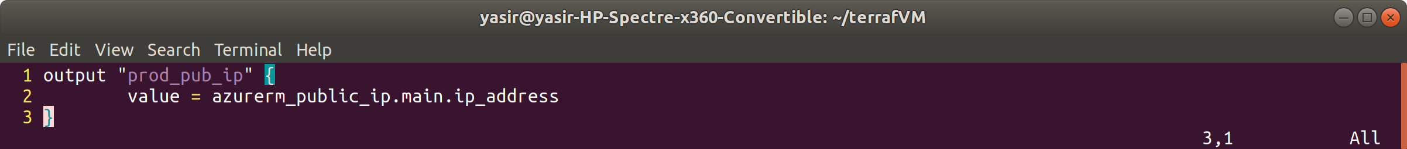

format files

$ terraform fmt

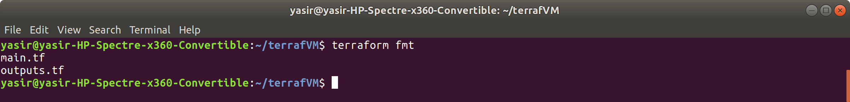

initialize terraform

$ terraform init

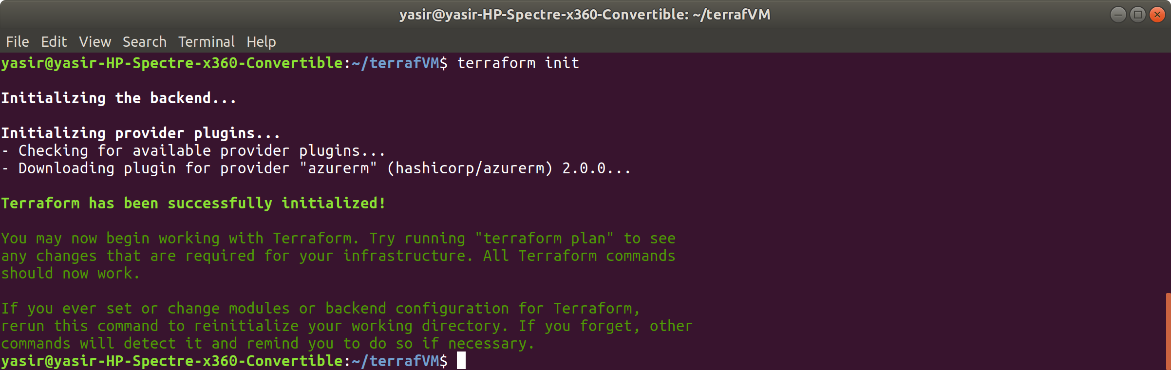

validate

$ terraform validate

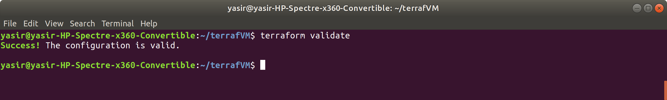

$ terraform apply

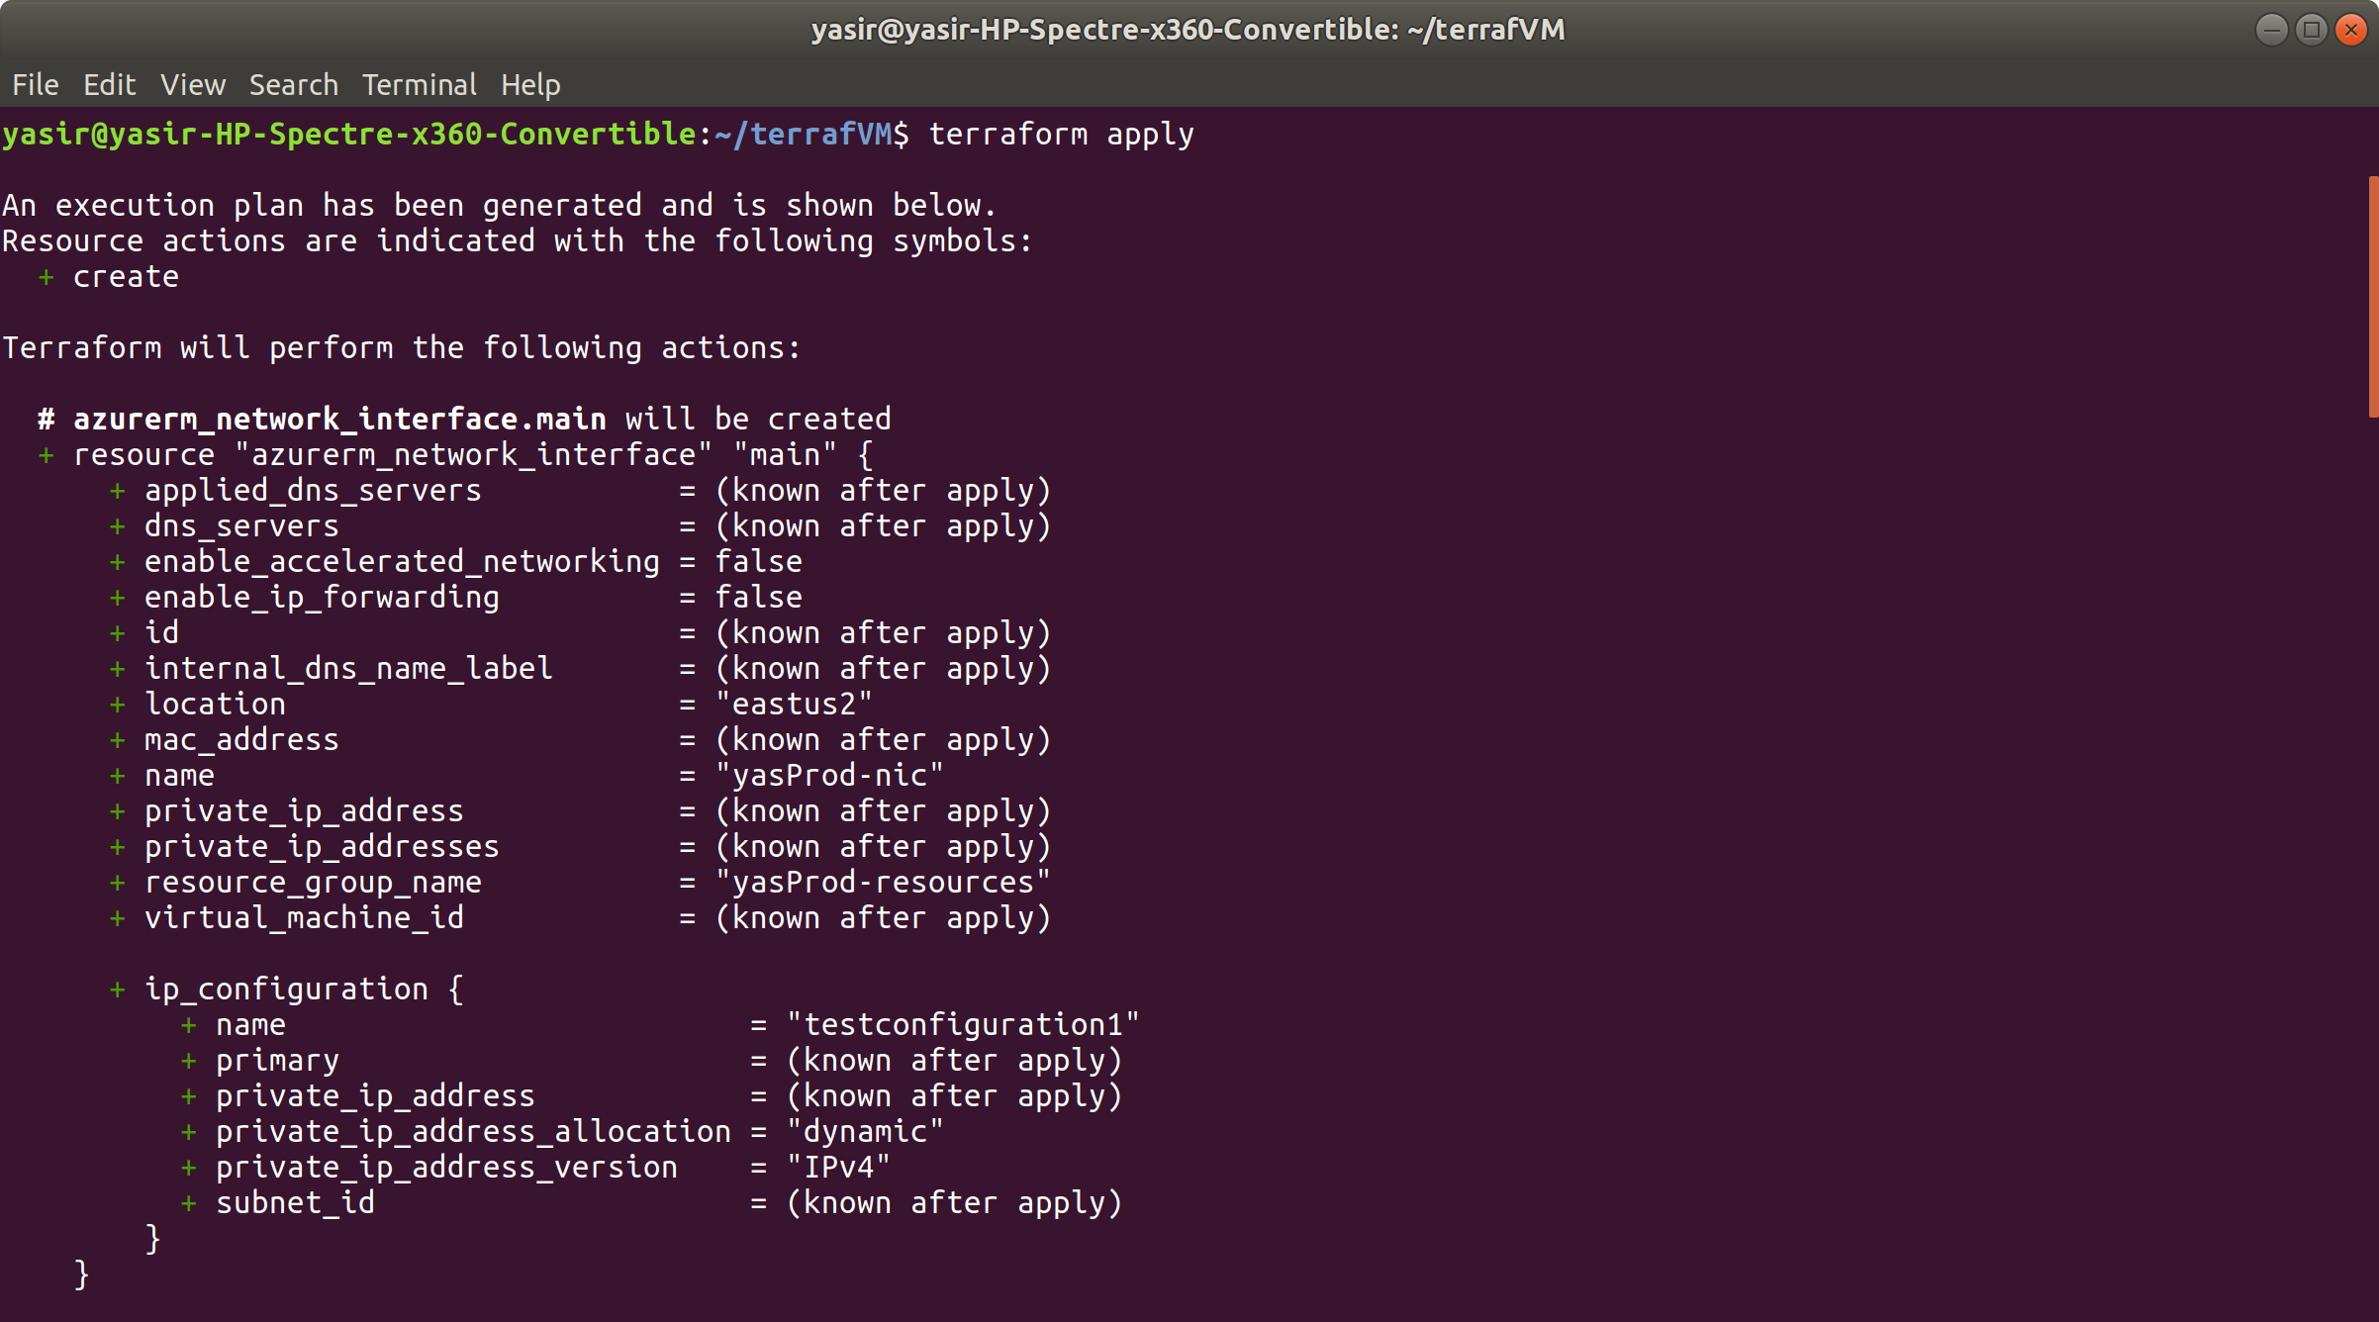



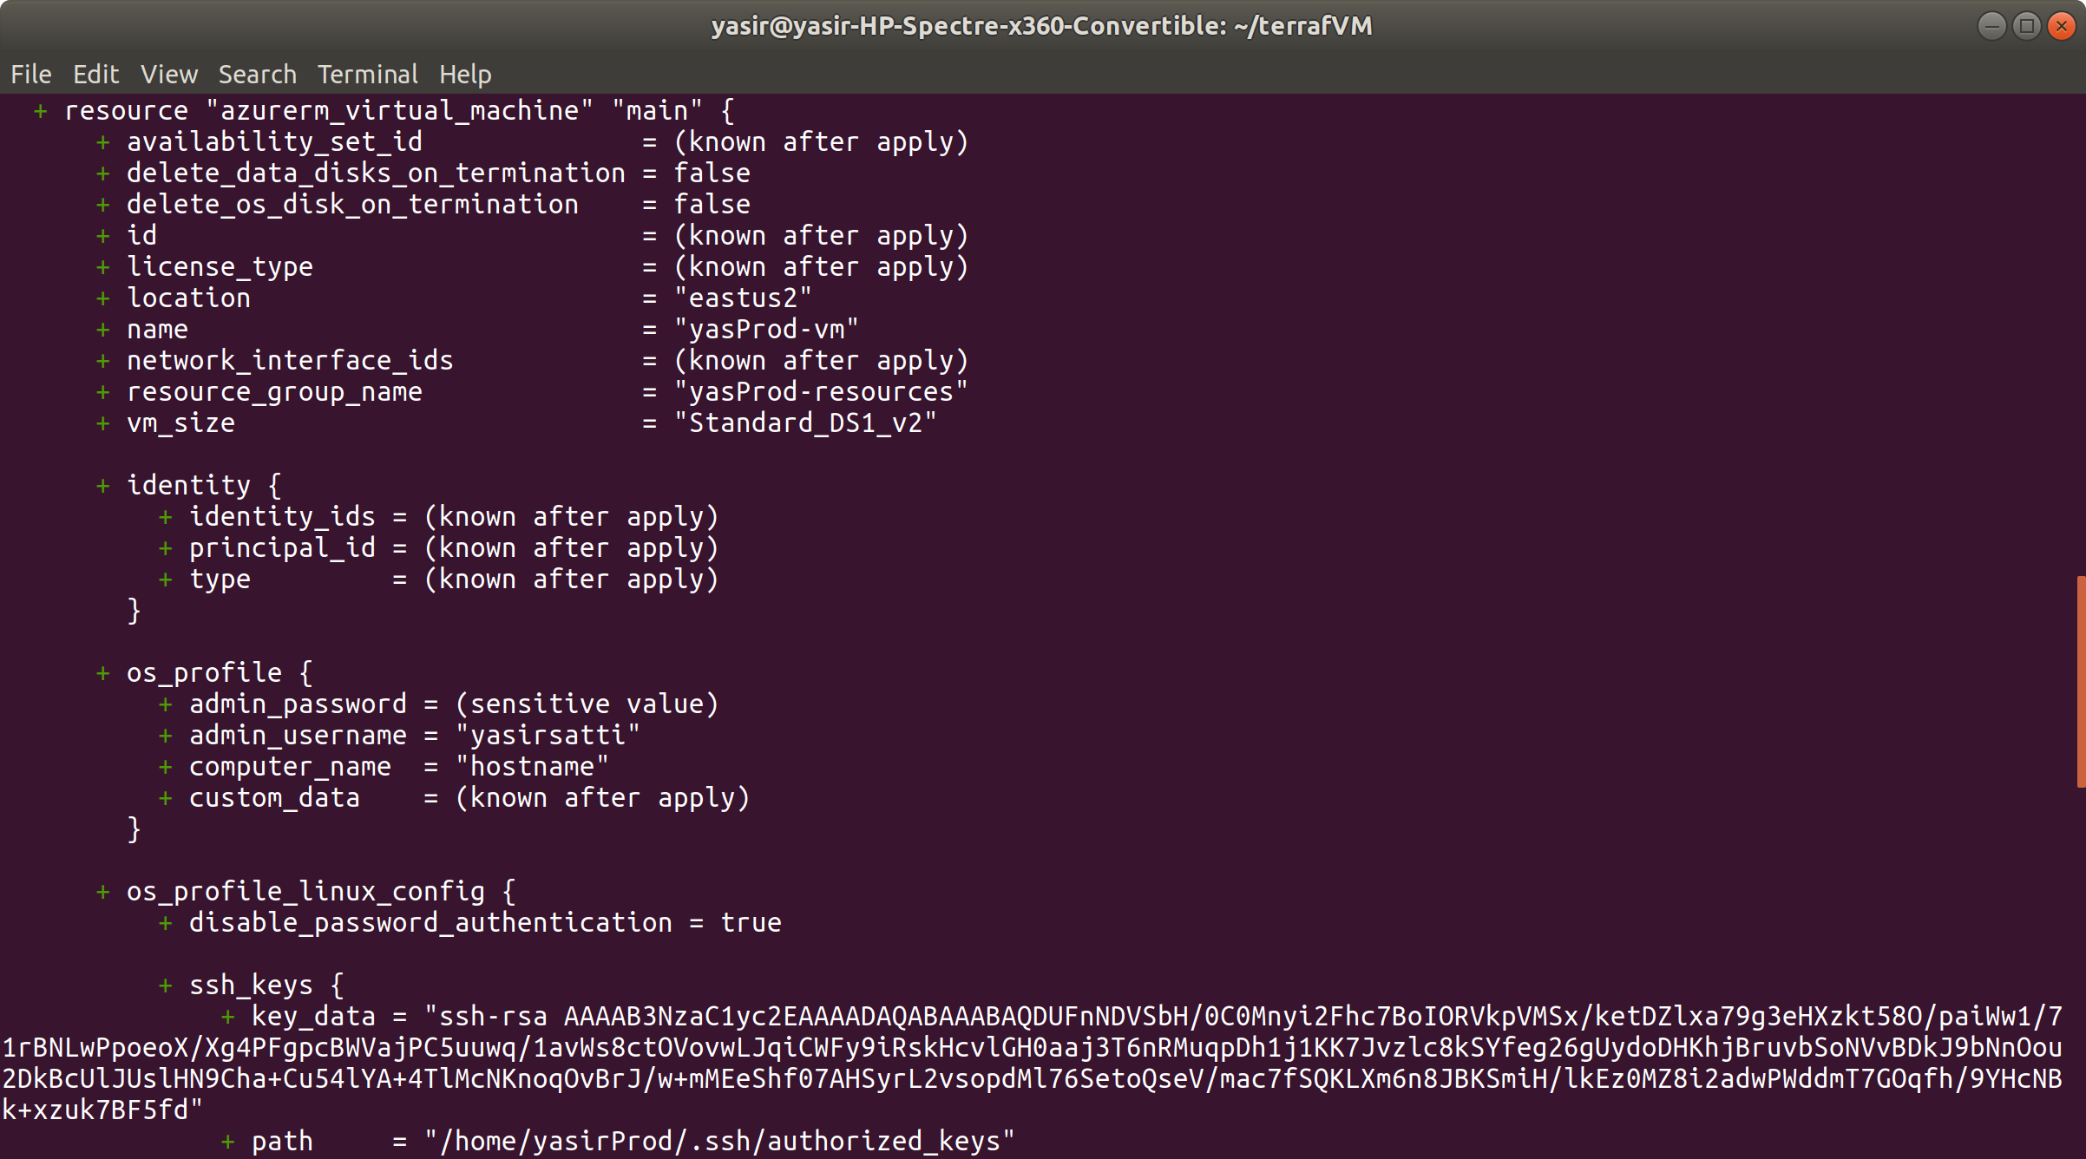

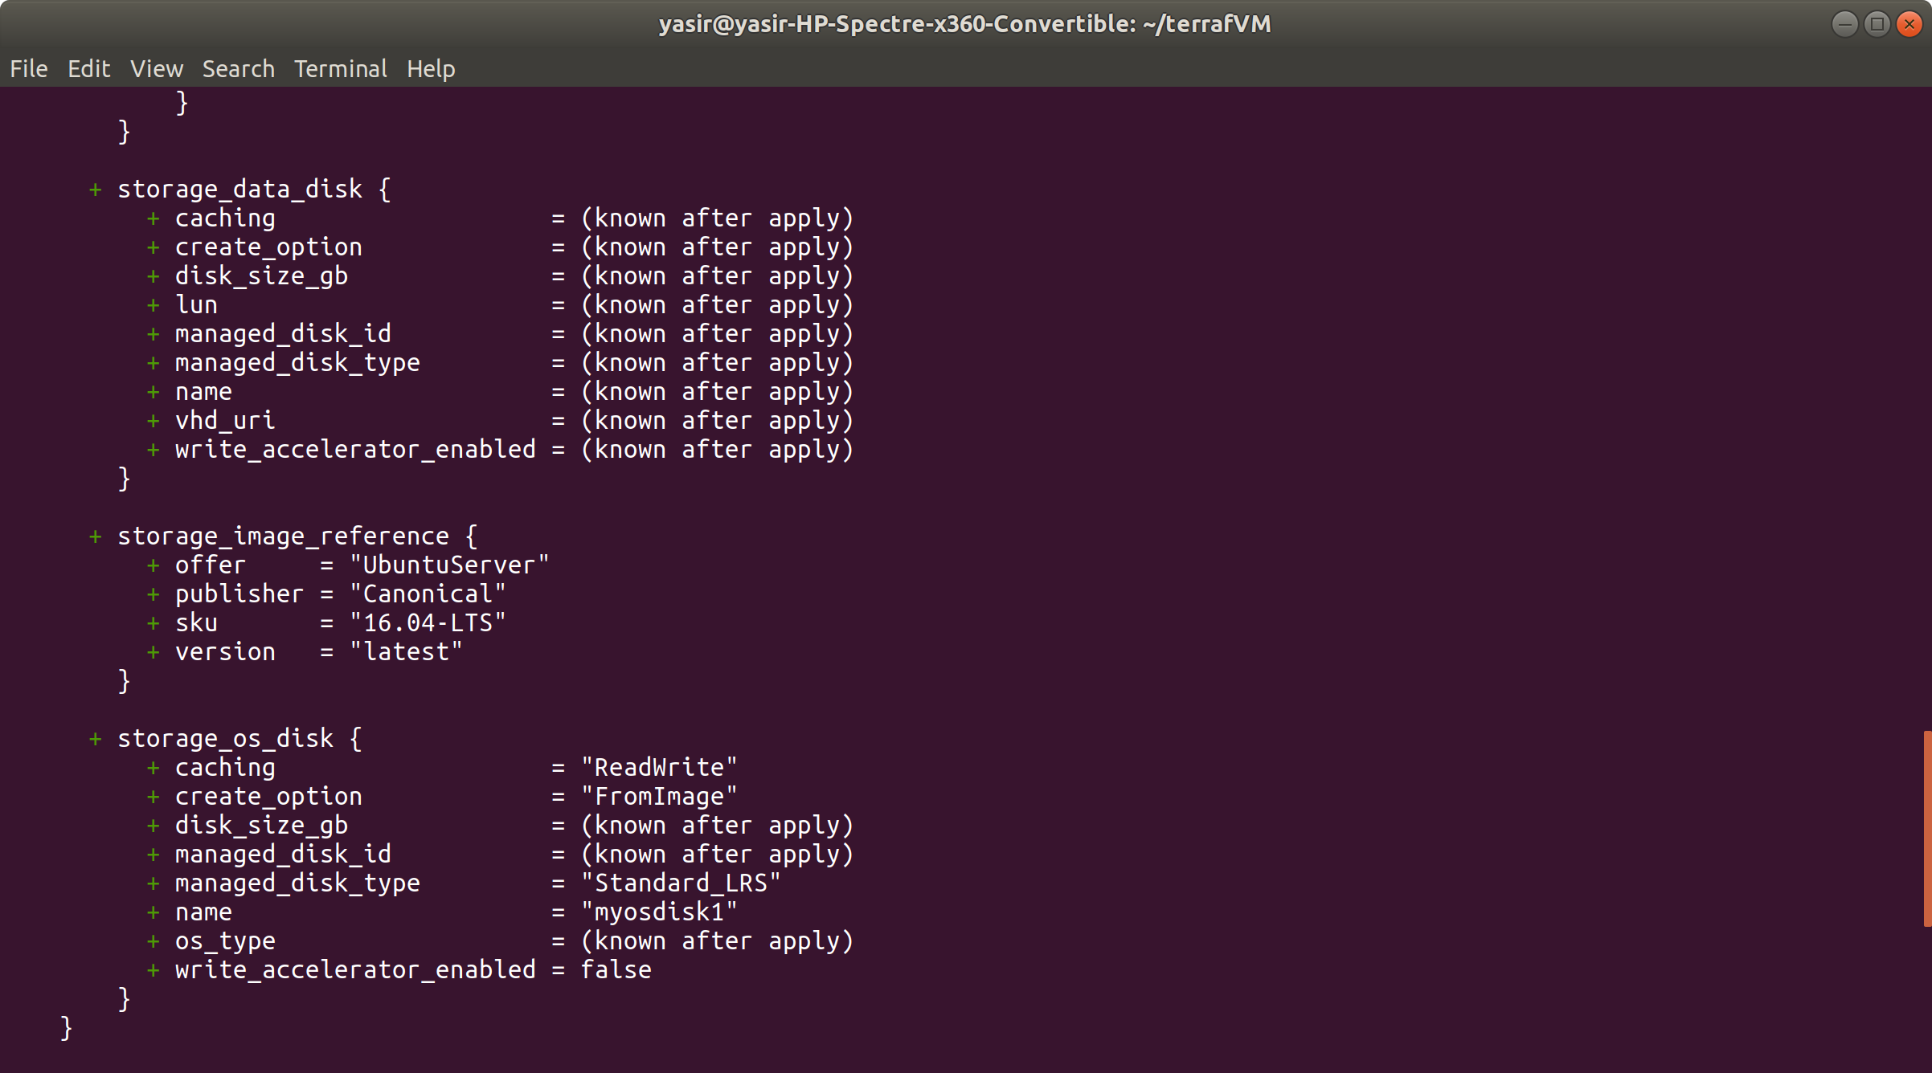

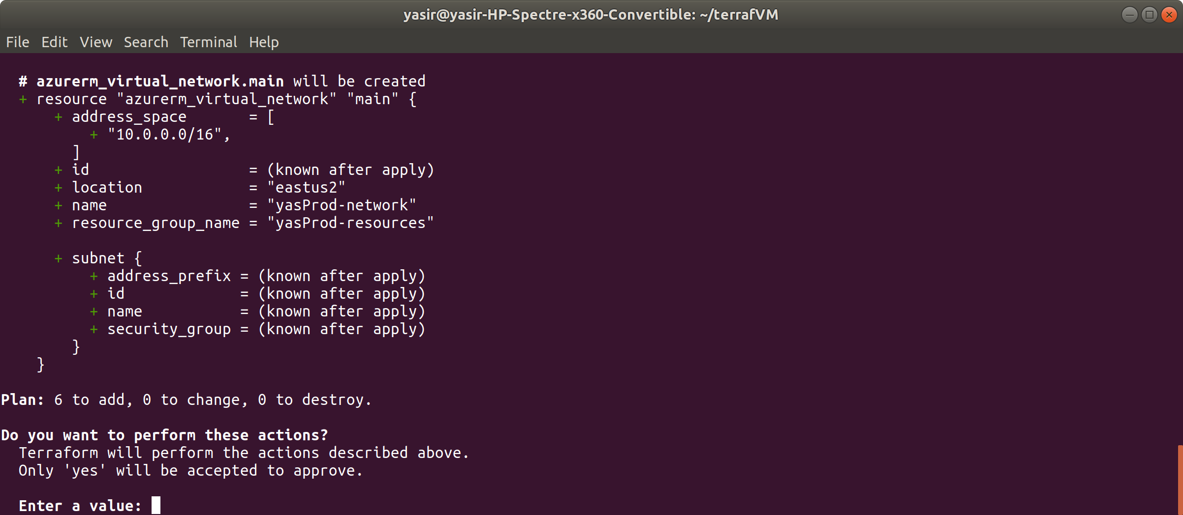

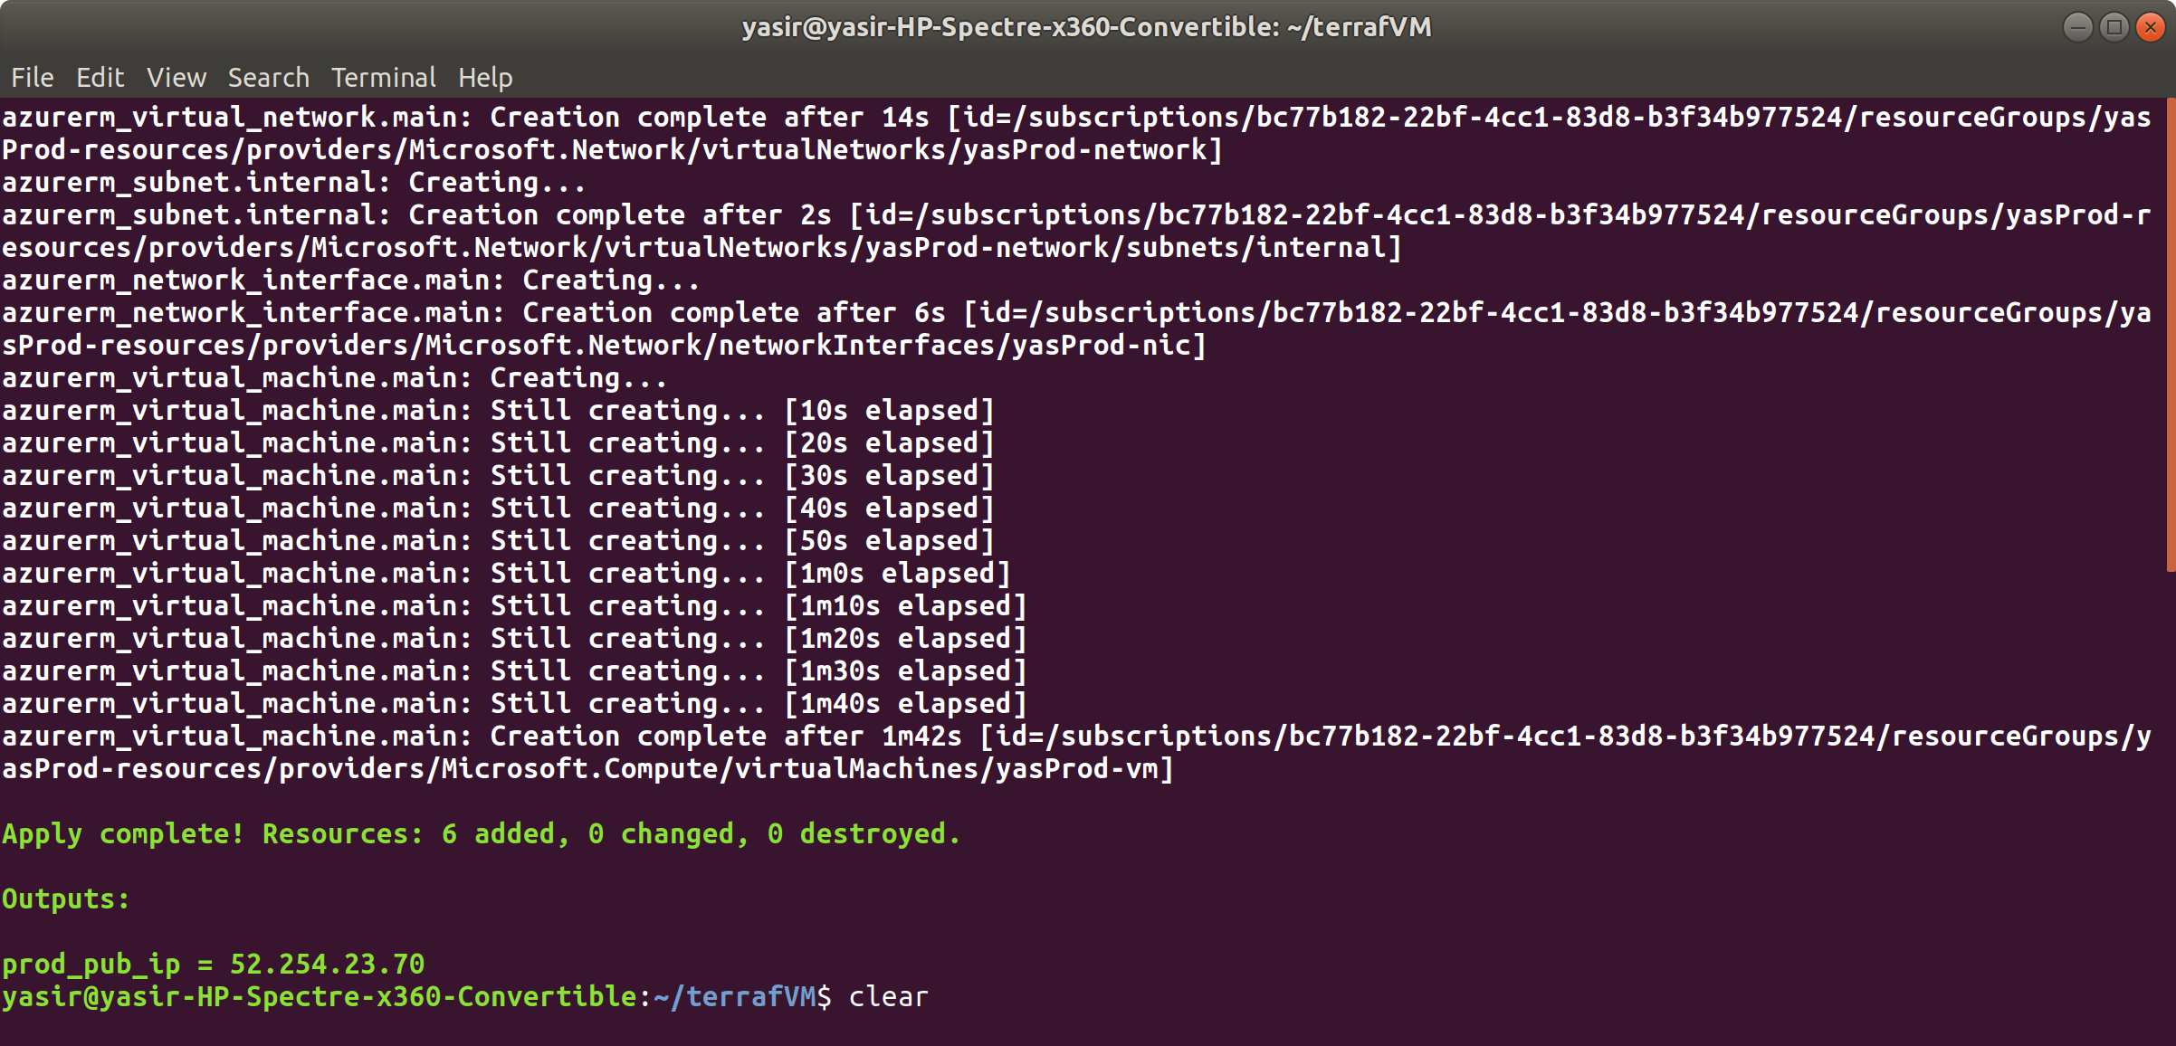

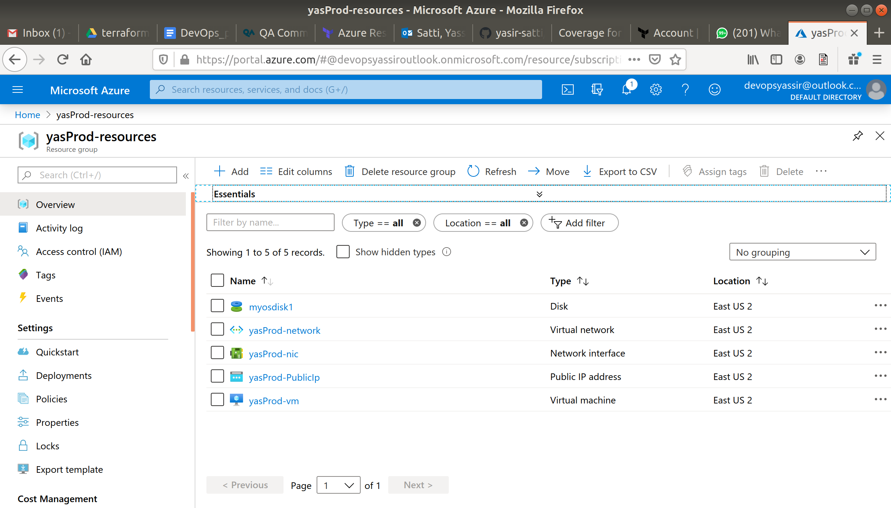

Now ssh to the new vm

$ ssh yasirsatti@$(terraform output prod_pub_ip)

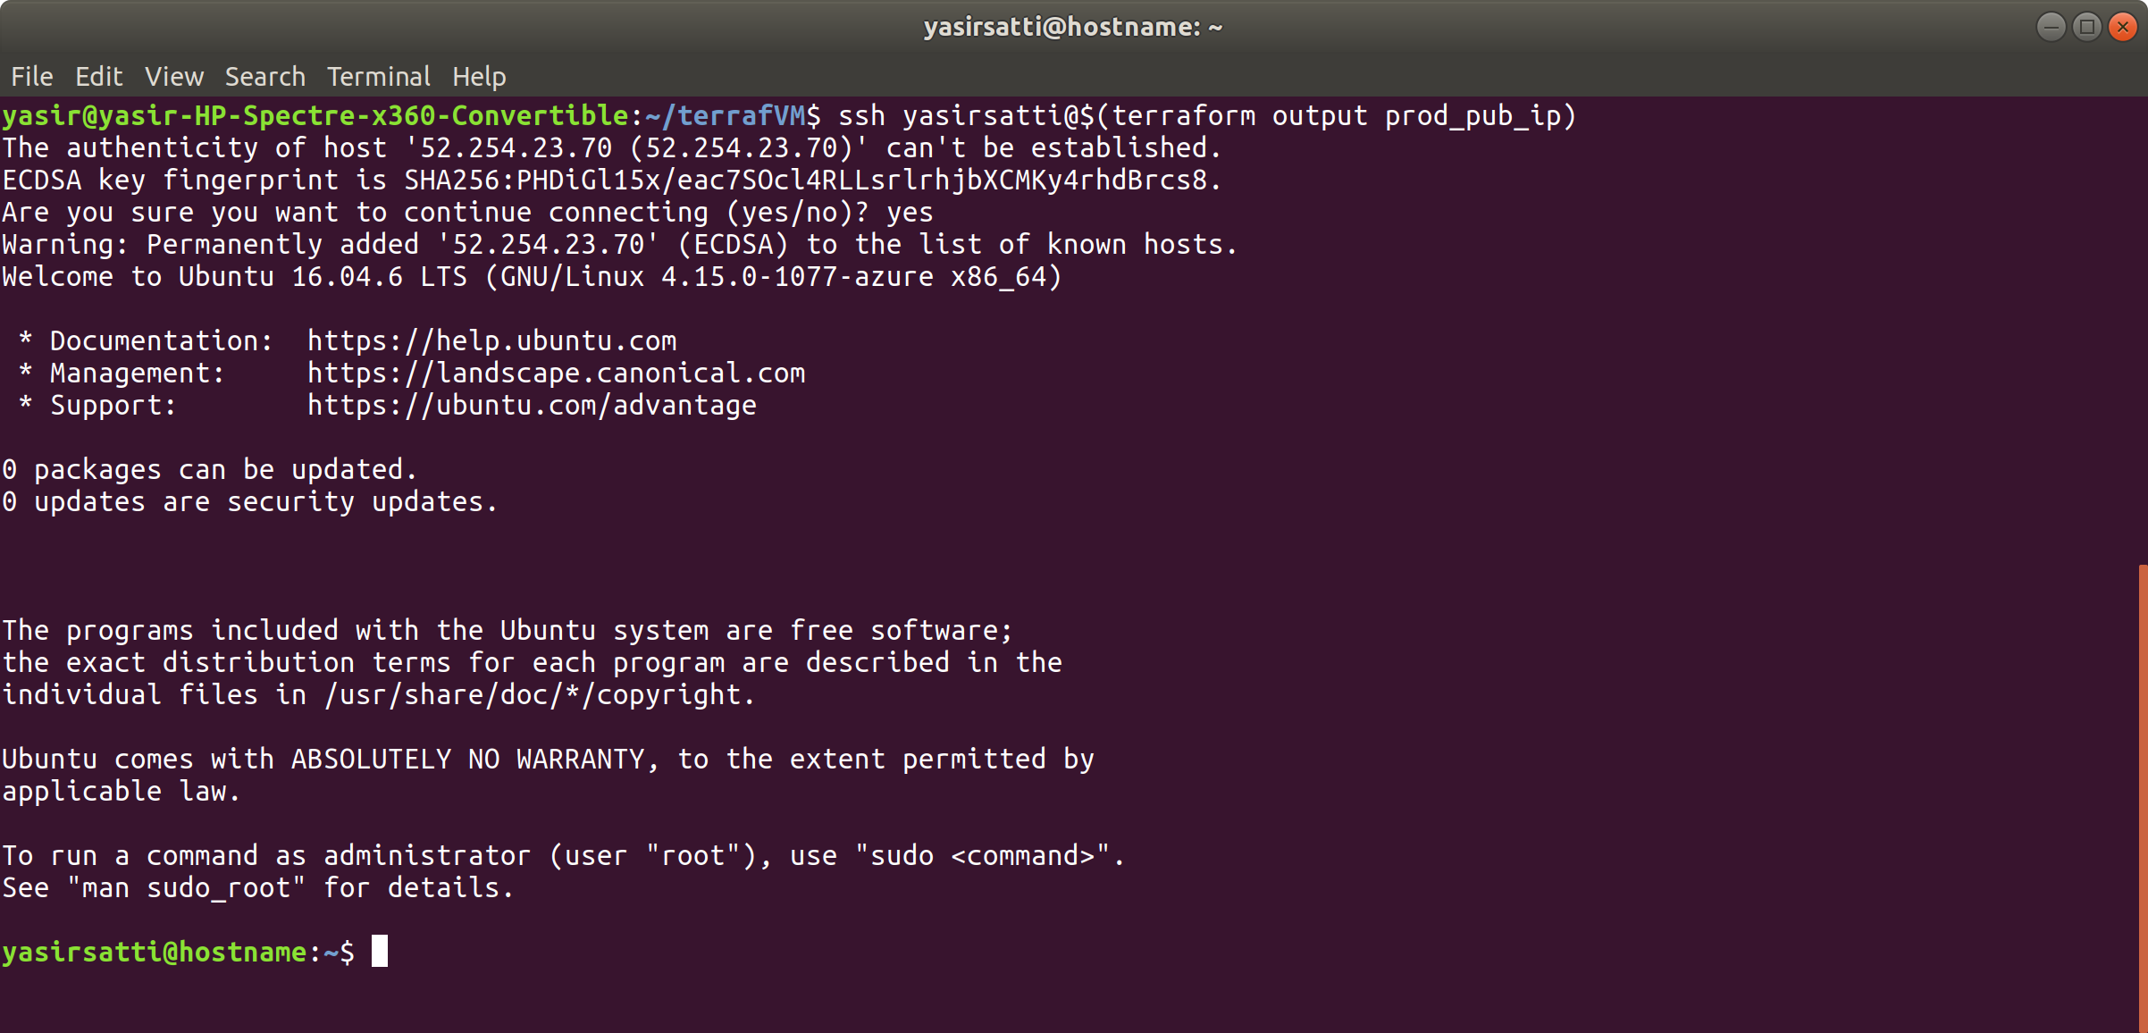

You can take some of the output and prepare it for use by other tools like Ansible

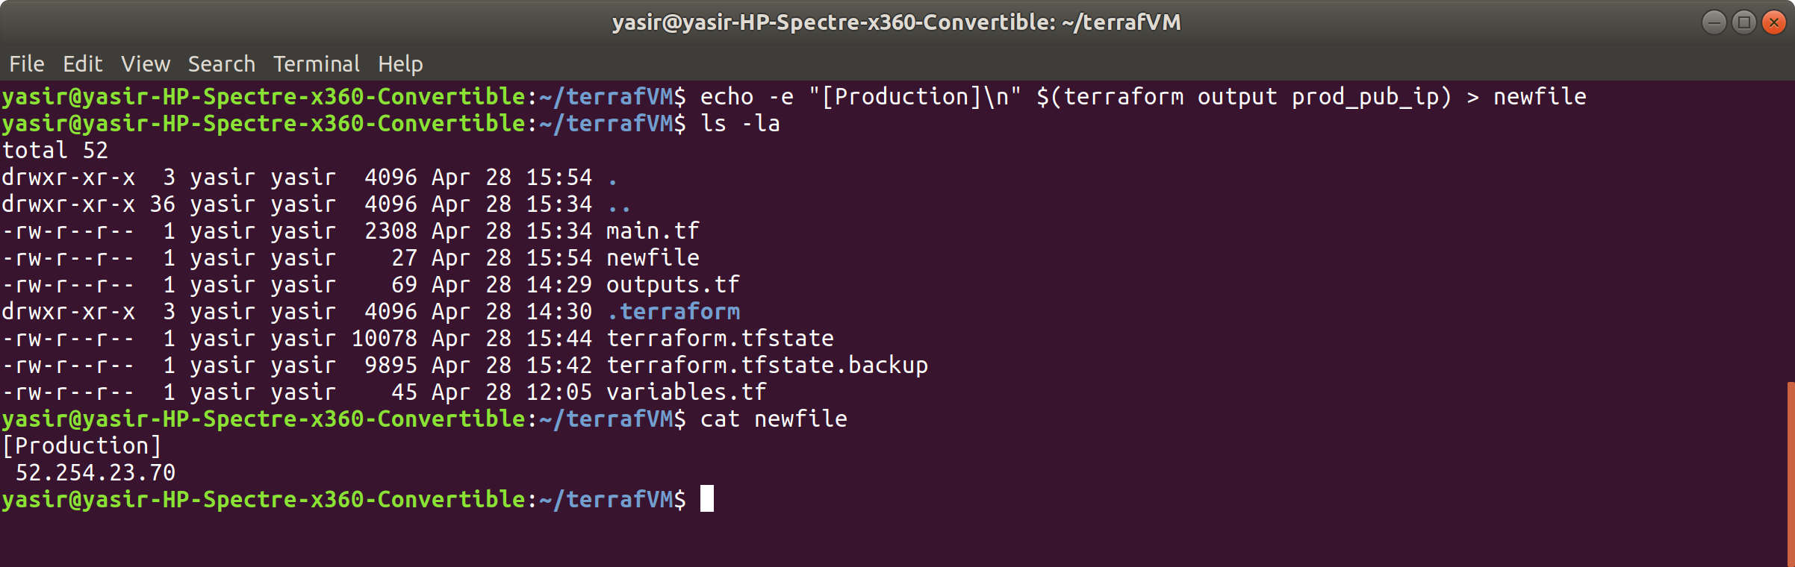

Clean up

$ terraform destroy

